**CineBooker: Scalable Movie Ticket Booking System with AWS**

**Project Description:**

CineBooker:  Scalable Movie Ticket Booking System with AWS  is a scalable movie ticket booking system built on AWS for the movie theater CineBuzz, leveraging Flask for backend development and hosted on AWS EC2 for optimal performance and availability. This innovative platform provides users with an intuitive interface to browse movie schedules, select seats, and complete transactions seamlessly. By utilizing Amazon RDS for efficient database management, CineBooker ensures reliable storage and retrieval of booking data while handling increased traffic during peak times with ease. The system offers real-time updates on seat availability and booking confirmations, empowering cinemas to streamline their ticketing operations and gain valuable insights into customer preferences. Ultimately, CineBooker transforms the movie ticketing experience, making it more accessible and user-friendly for movie goers.

**Scenario 1: Scalable Infrastructure for Movie Ticket Booking**

During peak movie release periods, CineBooker utilizes AWS EC2 to provide a highly scalable infrastructure that can adapt to fluctuating demands for ticket bookings. As audience interest surges for blockbuster films, the EC2 environment automatically scales to accommodate increased traffic, ensuring that users experience fast load times and uninterrupted service. Built on Flask, the backend efficiently processes user requests for seat selection, booking confirmations, and payment transactions. This seamless scalability allows CineBooker to handle everything from small independent films to major cinematic events without sacrificing performance or user experience.

**Scenario 2: Efficient Data Management with Amazon RDS**

CineBooker leverages Amazon RDS for effective data management, utilizing MySQL to securely store user profiles, booking details, and transaction histories. This managed database solution ensures high availability, automated backups, and rapid scalability, enabling the platform to efficiently process large volumes of booking data during peak times. With real-time data access, cinema operators can track ticket sales, analyse customer preferences, and generate insightful reports to optimize movie schedules and promotions. The reliable and secure storage provided by RDS enhances the overall user experience by ensuring quick retrieval of booking information and seamless transaction processing.

**Scenario 3: Secure User Access Management with AWS IAM**

To safeguard user data and ensure secure transactions, CineBooker employs AWS IAM for robust access management. The platform implements role-based permissions, granting specific access rights to users such as cinema operators, marketing teams, and data analysts. This ensures that sensitive information, including customer payment details and booking histories, is protected and only accessible to authorized personnel. With AWS IAM, CineBooker maintains strict security protocols while enabling stakeholders to analyse ticket sales, viewer demographics, and trends. This secure access approach, combined with the scalability of AWS EC2, allows CineBooker to manage user data effectively while ensuring a safe and reliable ticket booking experience.

AWS ARCHITECTURE

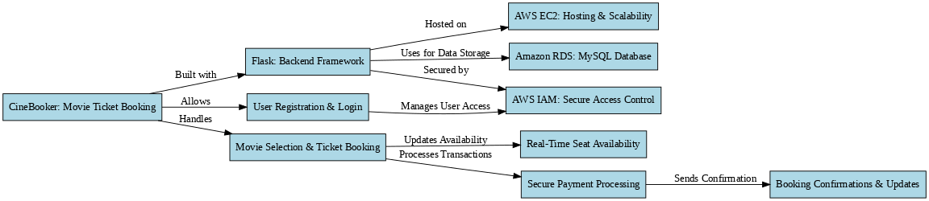

Entity Relationship (ER)Diagram:

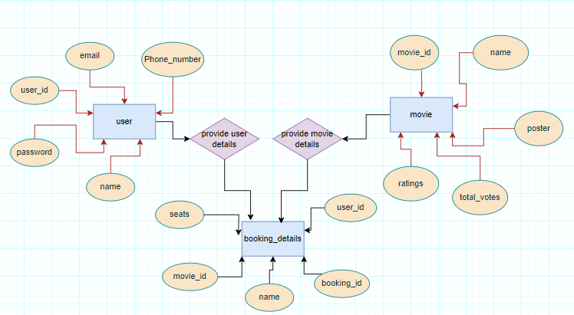

**Pre-requisites:**

### 1. AWS Account Setup: [https://youtu.be/CjKhQoYeR4Q?si=ui8Bvk_M4FfVM-D](https://youtu.be/CjKhQoYeR4Q?si=ui8Bvk_M4FfVM-Dh)h

### 2. Understanding of IAM: <https://youtu.be/gsgdAyGhV0o?si=3qg-bULgkD4LXNvR>

### 3. Knowledge of Amazon EC2 :<https://youtu.be/8TlukLu11Yo?si=MUj0nEAOESRhHUIz>

4. RDS : <https://www.youtube.com/live/MPau9c7PT74?si=A8OK-zFGbSKkAFWN>

5. MySQL Workbench: <https://youtu.be/wALCw0F8e9M?si=ovMF9qMx5rLxaznB>

**Project Workflow:**

### Project Flow

1. **AWS Account Setup and Login**
   * Set up an AWS account if not already done.
   * Log in to the AWS Management Console to manage resources.
2. **RDS Database Creation and Setup**
   * **Activity 2.1**: Create an RDS Instance.
   * **Activity 2.3**: Install MySQL Workbench.
3. **Frontend Development and Application Setup**
   * **Activity 3.1**: Build the Frontend.
4. **EC2 Instance Setup**
   * **Activity 4.1**: Launch EC2 Instance.
5. **Deployment on EC2**
   * **Activity 5.1**: Deploy to EC2.
6. **Testing and Deployment**
   * **Activity 6.1**: Functional Testing.
   * **Activity 6.2**: Deployment.

**Milestone 1: AWS Account Setup and Login**

* **Activity 1.1: Create AWS Account**
  + Sign up for an AWS account and configure billing settings.

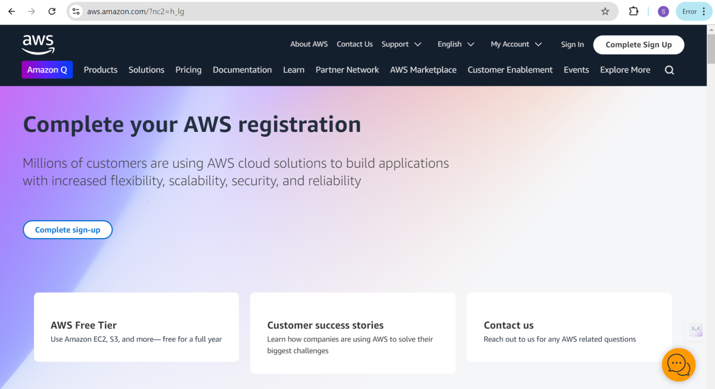

* **Activity 1.2: Login to AWS Management Console**
  + Access the AWS Management Console using your login credentials.

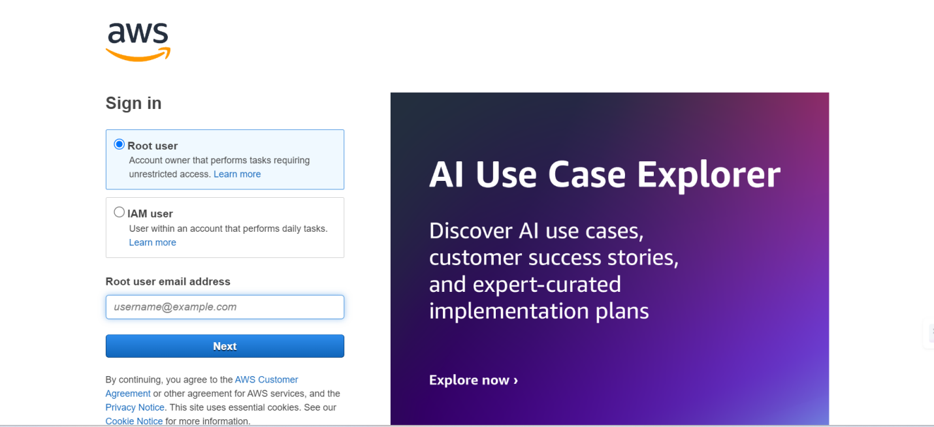

**Milestone 2: RDS Database Creation and Setup**

* **Activity 2.1: Create an RDS Instance**
  + Choose the RDS service from the AWS Management Console.

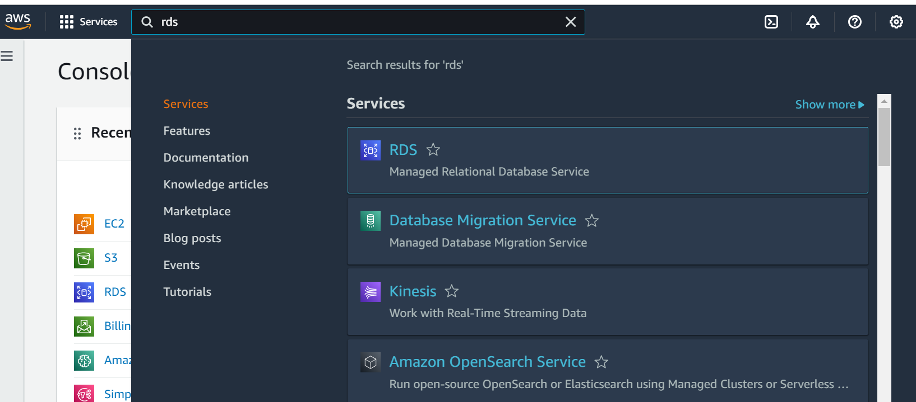

* Click on Create database either on Dashboard or Databases Console

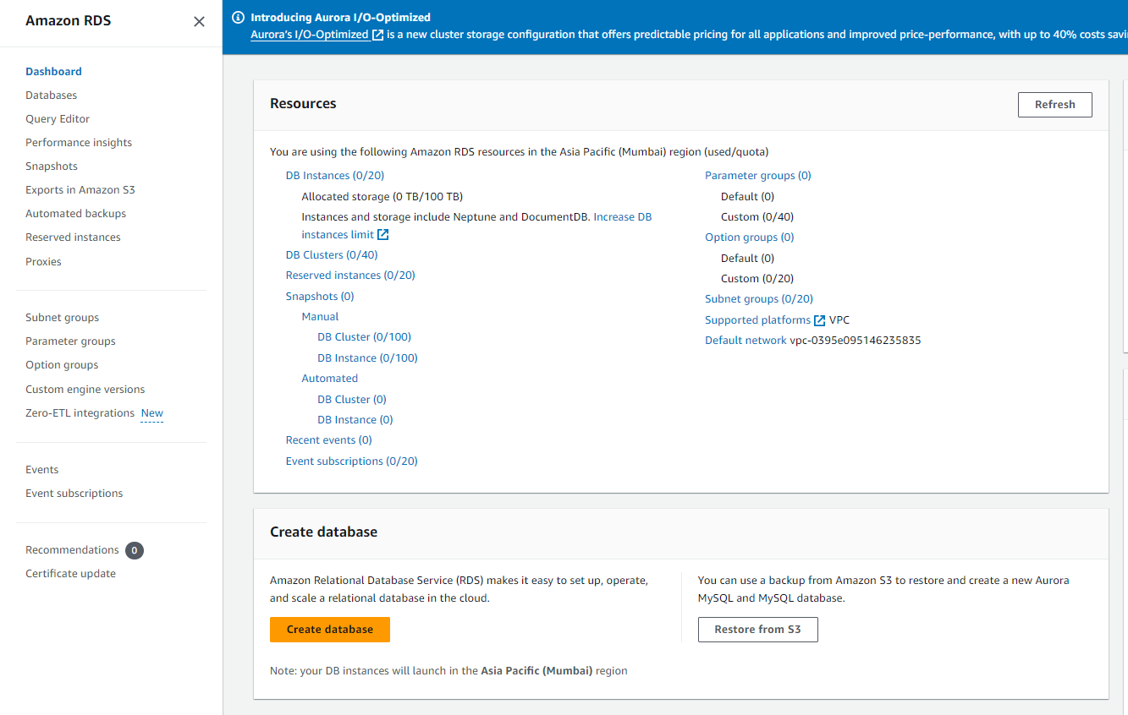

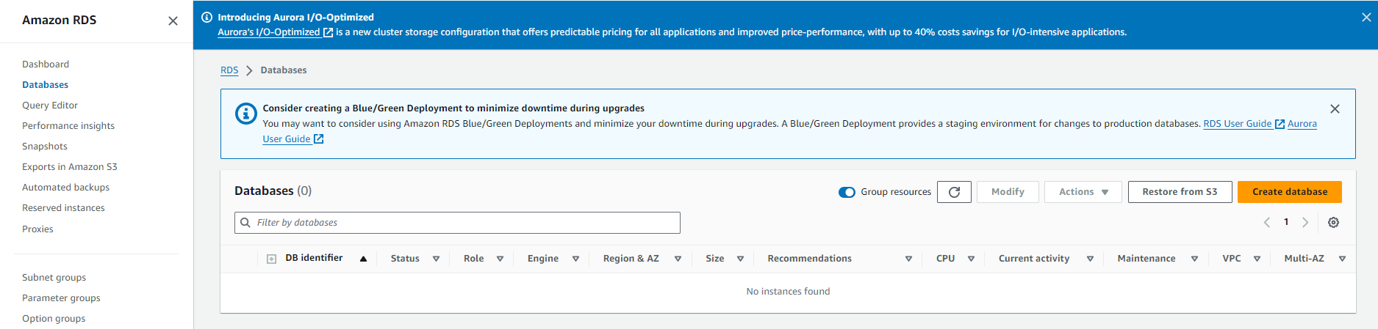

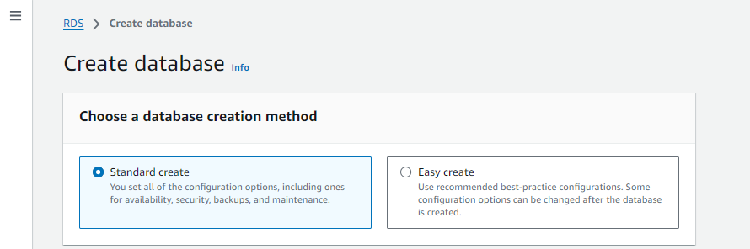

* + Select MySQL as the database engine, configure the instance settings (e.g., storage, instance class), and launch the RDS instance.

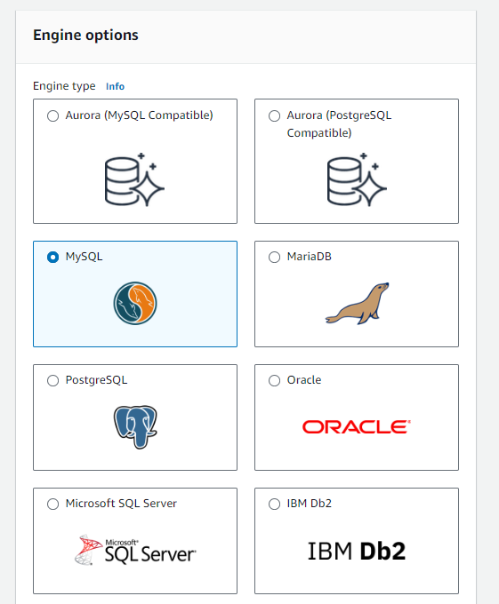

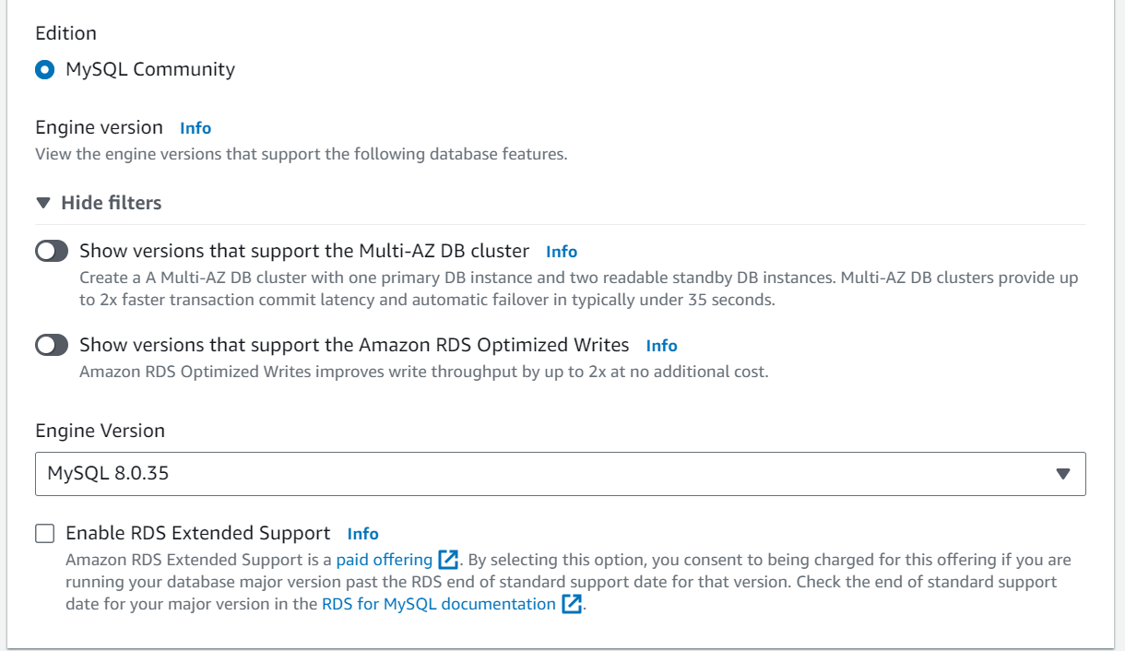

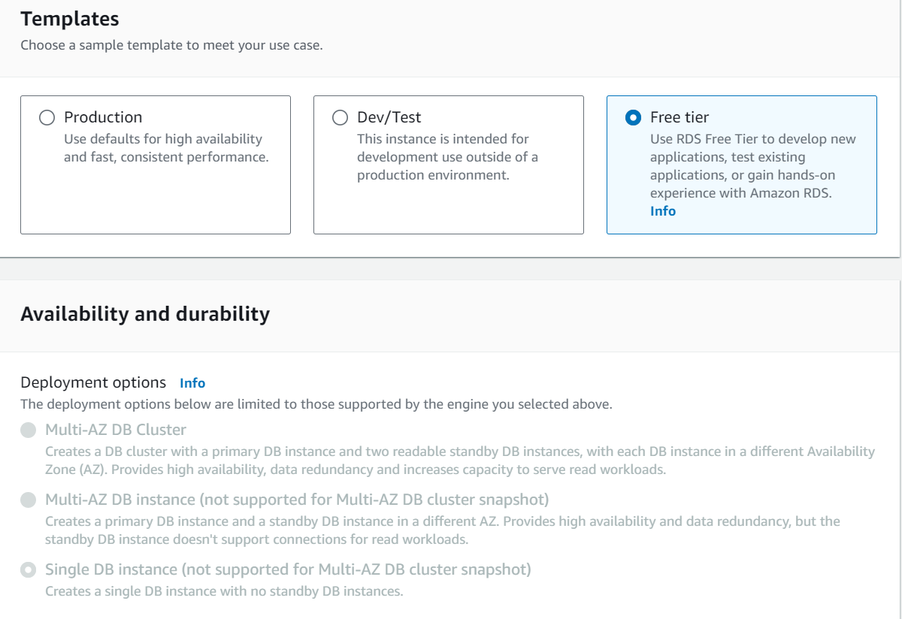 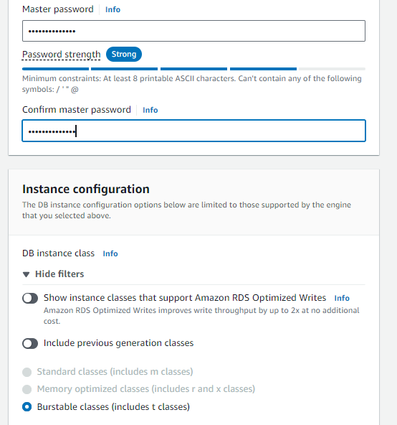

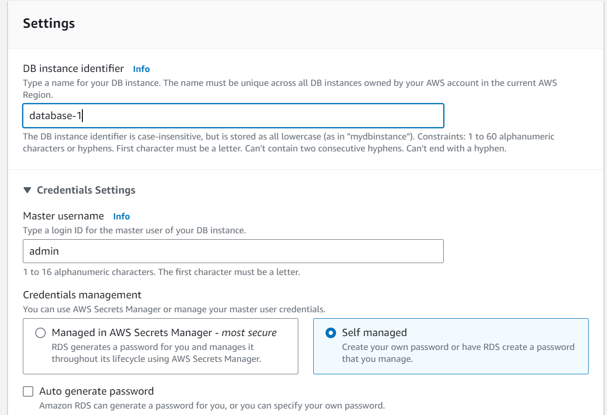



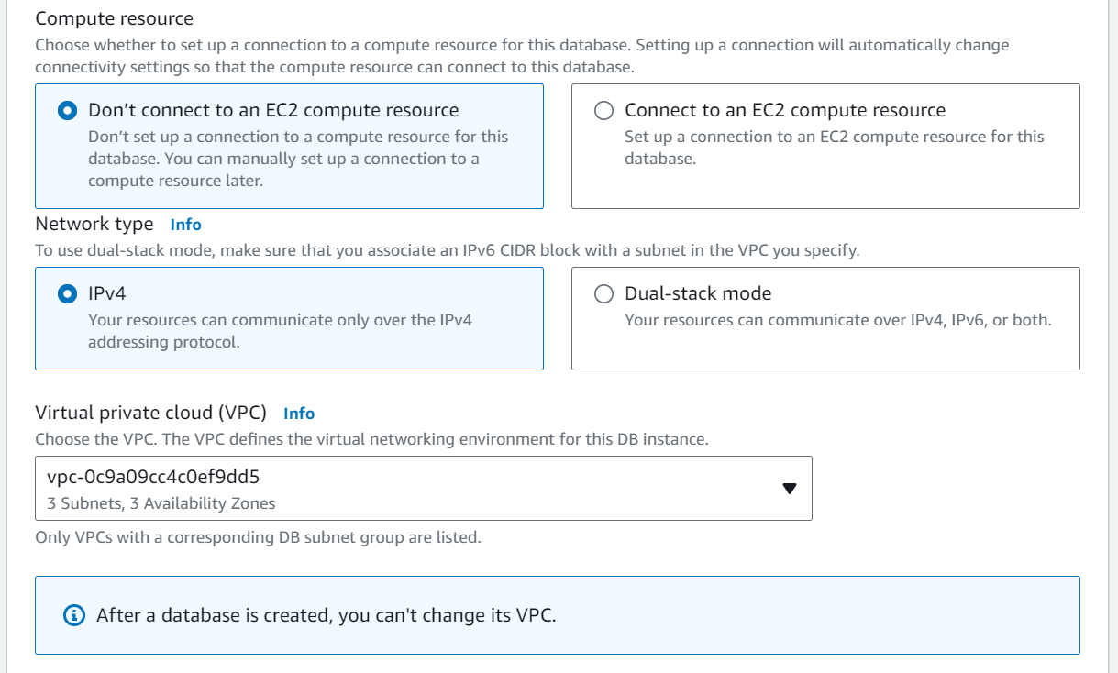

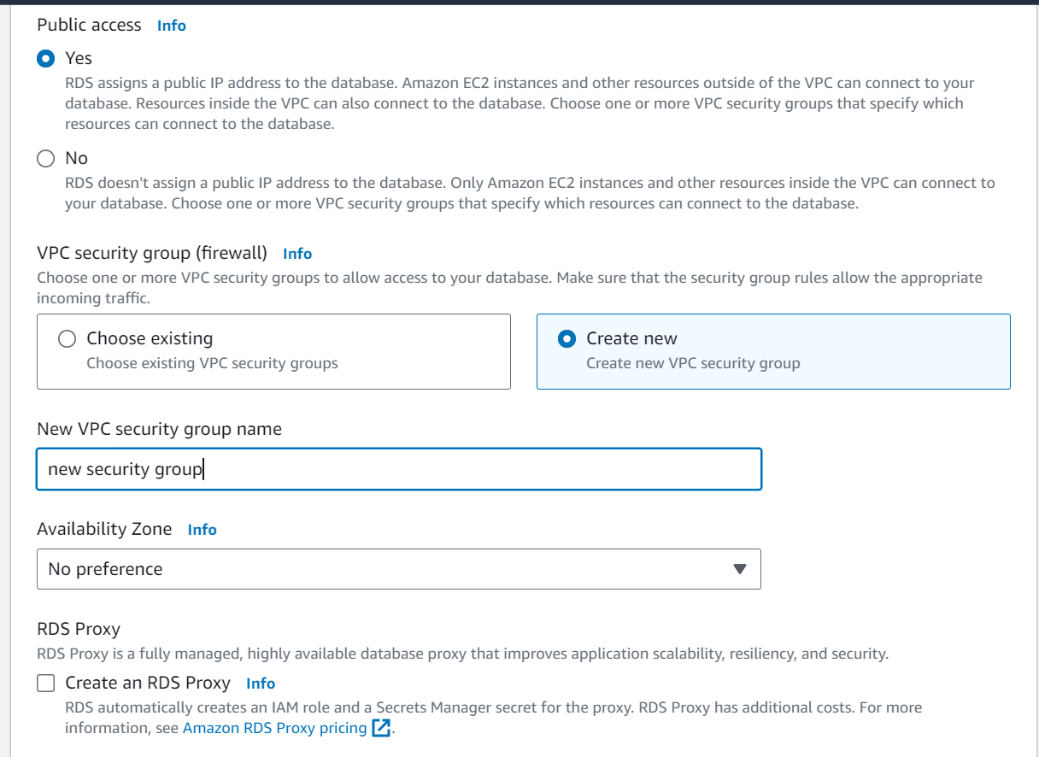

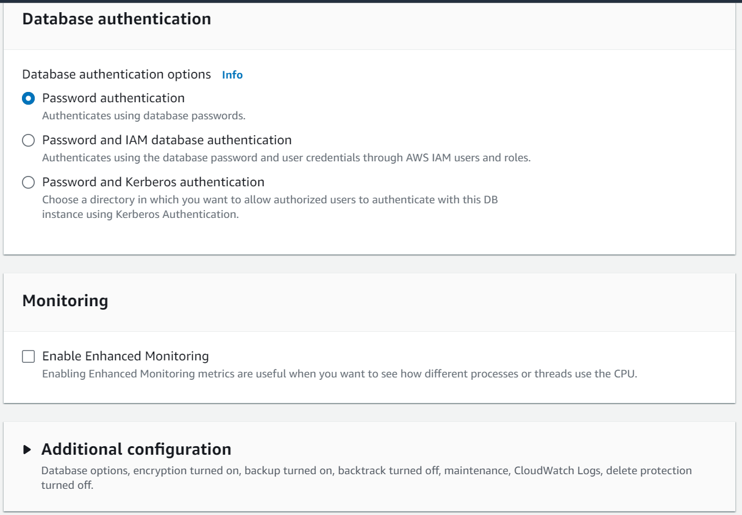

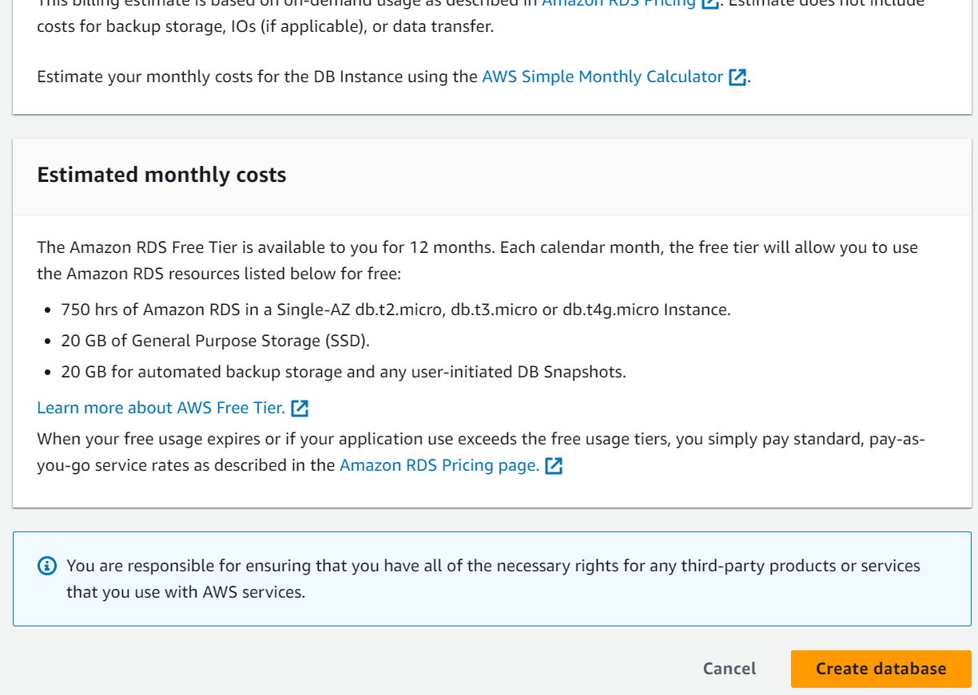

* **Activity 2.2: Configure Database Access**

Set up security groups, create database credentials, and configure access policies to ensure secure connectivity to the database.

* Copy Endpoint Link

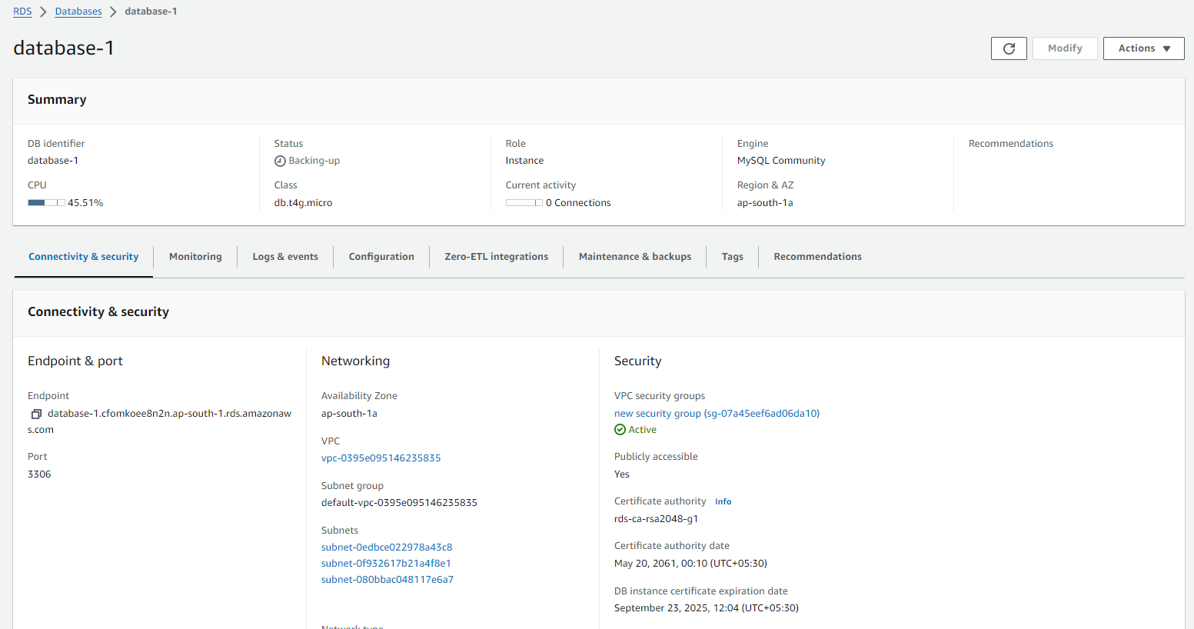

* **Activity 2.3: Install MySQL Workbench**
  + Download and install MySQL Workbench on your local machine for database management.

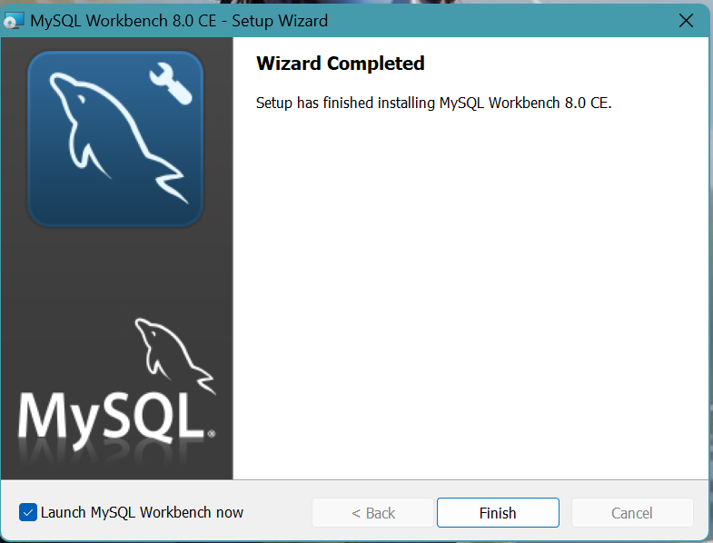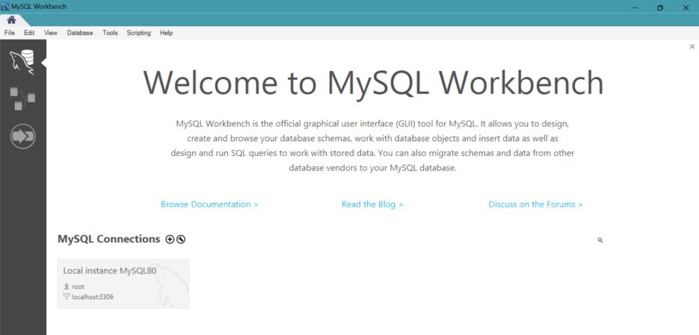

* + Connect to the RDS instance via MySQL Workbench using the endpoint and credentials from AWS

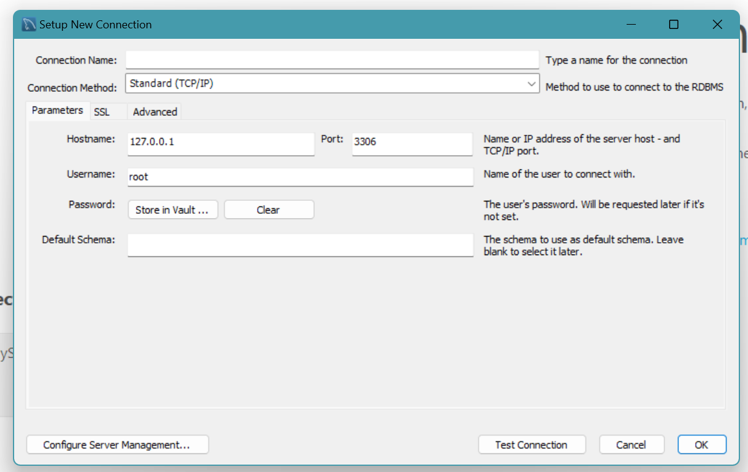

* Give a connection name.
* Copy the endpoint from the RDS database that is created in AWS and paste it in **Hostname.**
* Write the username and enter the password , then click on **Test Connection**.
* Once the connection is successful, you’ll be welcomed with this interface

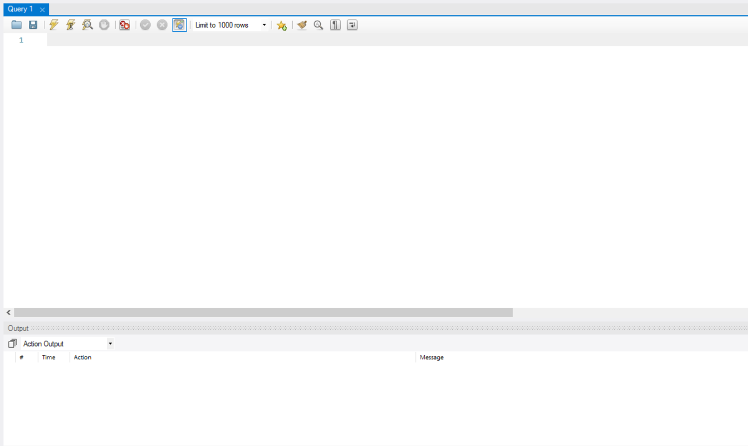

**Activity 2.4: Create the Database and the tables which are required.**

* Create a basic database schema for a public transport schedule and complaint management system.

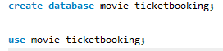

**Tables Created :**

1. **Users:**

* Stores user information such as  email, Phone_number, name, password.
* Each user has a unique ID (user_id), which serves as the Auto increment primary key

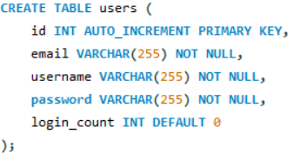

1. **Movie:**

* Contains movie details, including the name(movie name), ratings, total_votes, poster(movie poster url)
* Each movie is assigned a unique identifier (id), which is the primary key.
* The total_votes column represents the total count of reviews for a specific movie.
* The ratings column reflects the rating of a specific movie .

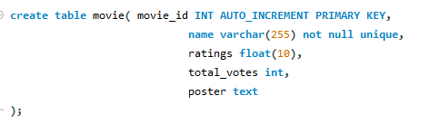

1. **Booking_details:**

* Contains booking_details including user_id, name(user name), movie_id, seats.
* Each booking_detail is assigned a unique id (booking_id), which is the primary key.

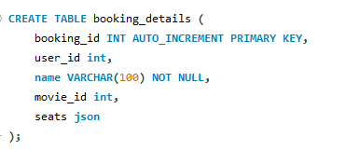

1. **Data Retrieval:**

We retrieved data from each table to view the stored information, including feedback details and movie details.

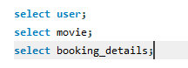

**Milestone 3: Frontend Development and Application Setup**

* **Activity 3.1: Build the Frontend**

Develop HTML, CSS, and Python-based Flask application files for CinemaBooker frontend interface.

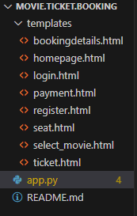

### Integrate Application with RDS

Connect app.py (Flask application) to the MySQL RDS database by configuring database connection settings and verifying connectivity.

1. **Flask App Initialization: Initializes a Flask application with a secret key for sessions.**

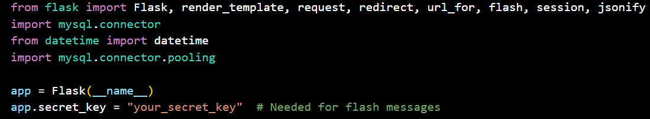

1. **Database Configuration: Configures MySQL RDS with connection pooling for efficient database access**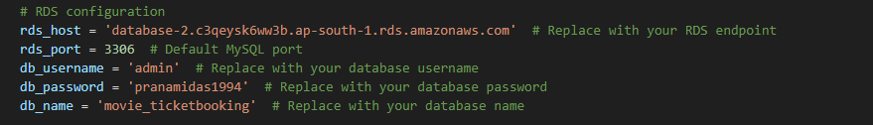

1. **Connection Pool: Uses MySQL connection pooling to handle multiple database connections.**

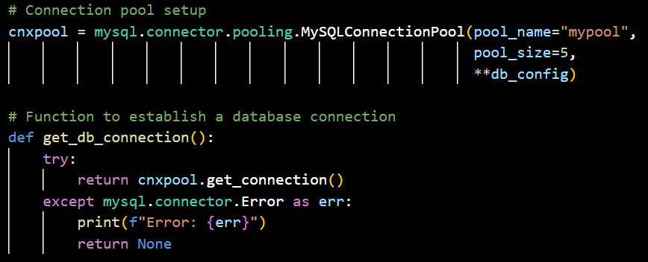

1. **Home Route: Renders the home page template when the root URL is accessed.**

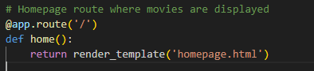

1. **Register Route:**

* Store user data: It stores user information in the database.
* Rendering the register page: After retrieving the movie data, it renders the register.html template.

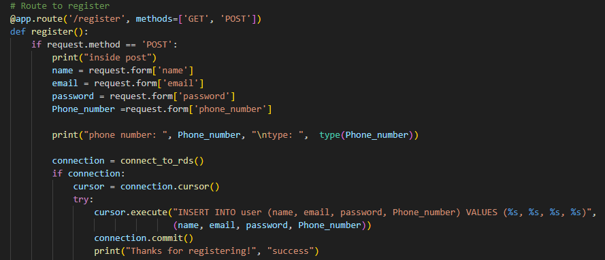

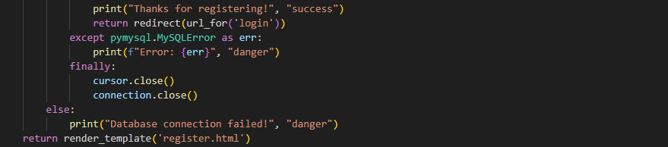

1. **Login Route: Login into the application using user email and password**

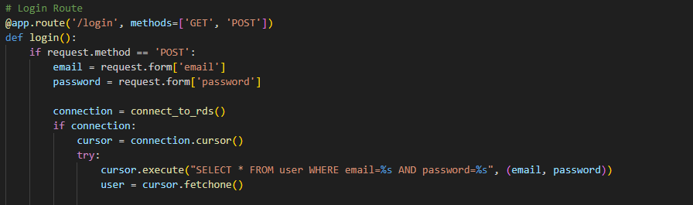

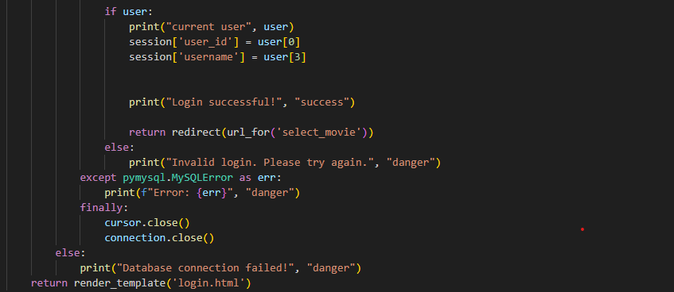

1. **Select_movie Route(GET/POST):**

* Display movie data: It displays recently released movie information.
* Insert movie data: Insert the selected movie in the database
* Rendering the selected_movie page: After retrieving and storing the selected movie data, it renders the selected_movie.html template.

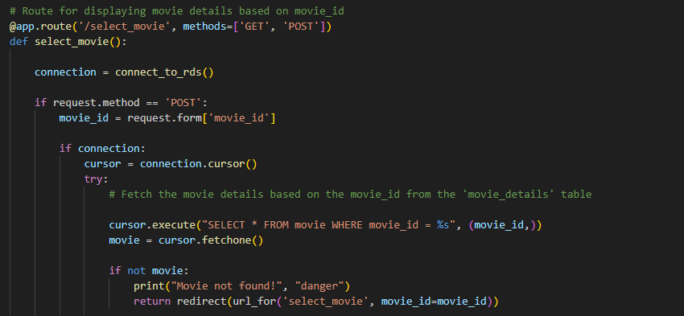

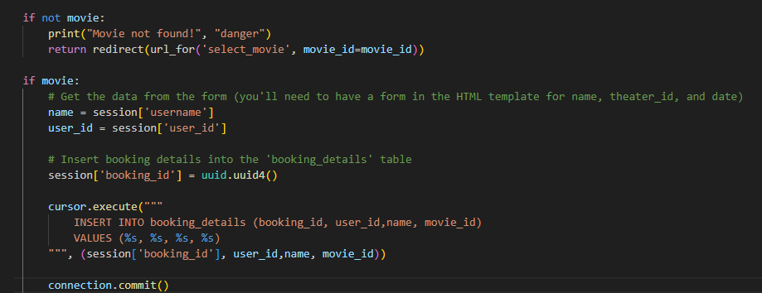

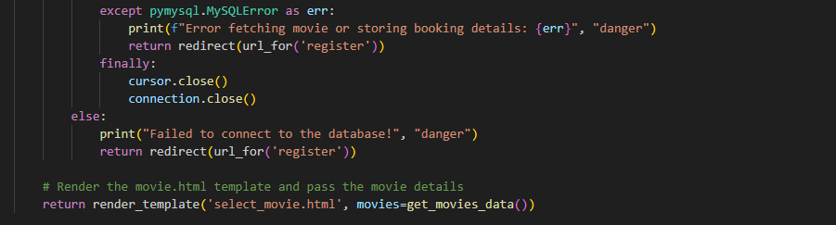

1. **Seat Route(GET/POST):**

* Insert seat data: It display seats and  Insert the selected seat data in the database
* Rendering the seat page: After storing the selected seat data, it renders the seat.html template.

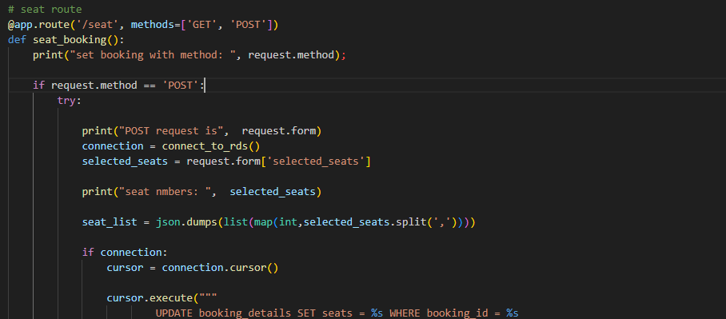

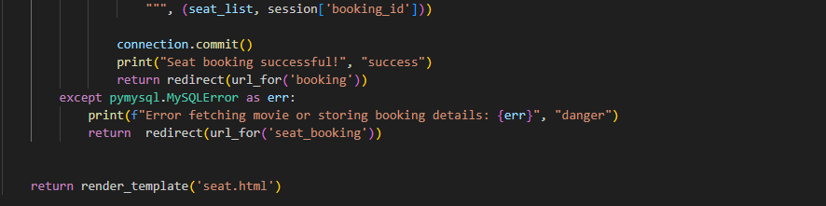

1. **bookingdetails Route(GET/POST):**

* Display booking details: It display booking details(movie name, theater name, user name, seats, total price) from the database
* Rendering the bookingdetails page: After displaying the booking  data, it renders the bookingdetains.html template.

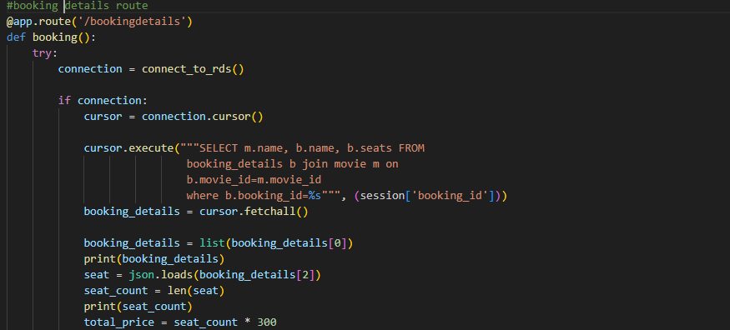

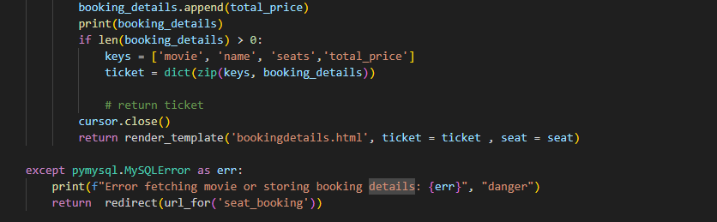

1. **payment Route():**

* Display payment options: It displays payment options for ticket booking.

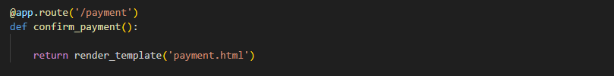

1. **ticket Route(GET/POST):**

* Display booking details: It displays the ticket by fetching the data from the database.
* Rendering the ticket page: After displaying the ticket, it renders the ticket.html template.

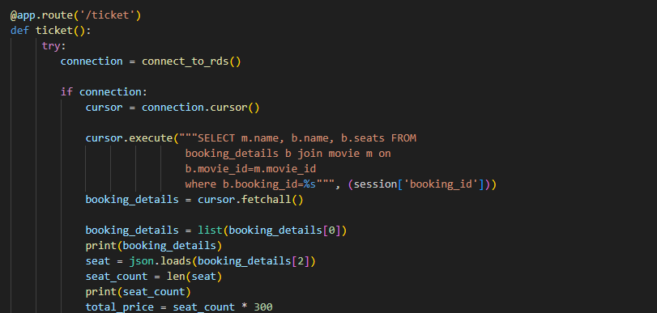

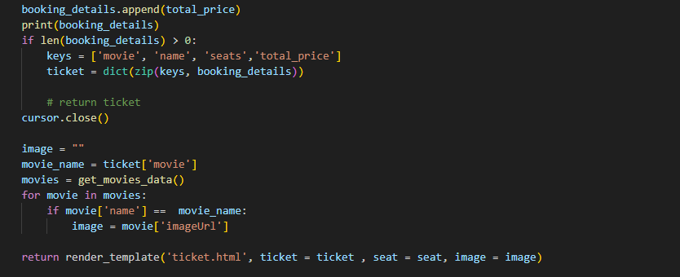

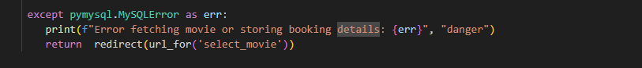

1. **Database Queries: Uses SQL queries to interact with MySQL RDS for user, movie data and bookingdetails.**
2. **Session Management**: Utilizes Flask session to store user,  movie data and booking details for seamless navigation within the "CinemaBooker” application.

**Milestone 4: EC2 Instance Setup**

* EC2 instance setup involves launching a virtual server on AWS, selecting an instance type, configuring security settings, and connecting via SSH. It allows hosting applications and managing workloads in the cloud.
* **Activity 4.1: Launch EC2 Instance**
* Choose a Linux-based EC2 instance from the AWS Console to host the CinemaBooker application.

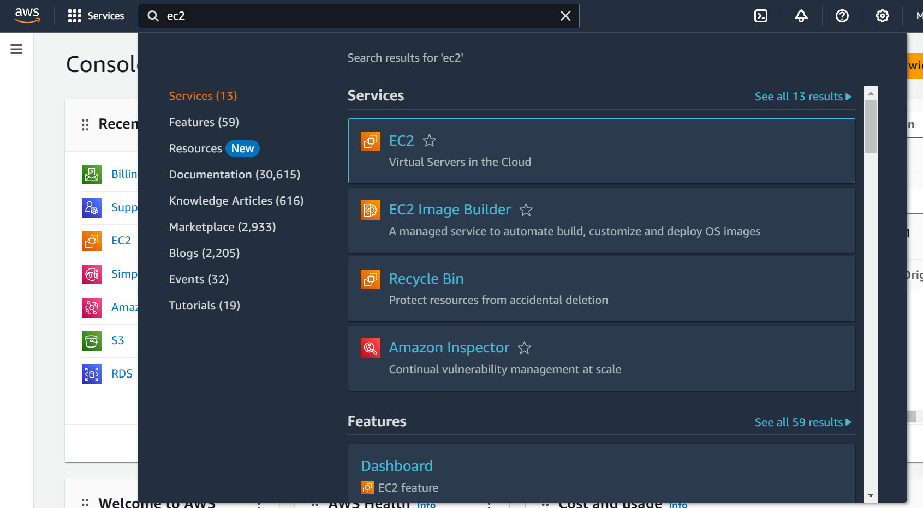

* Click on Launch instance to launch EC2 instance

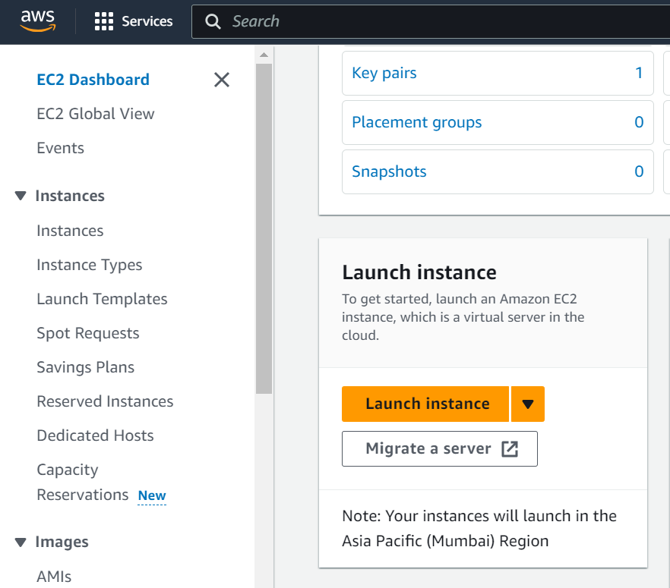

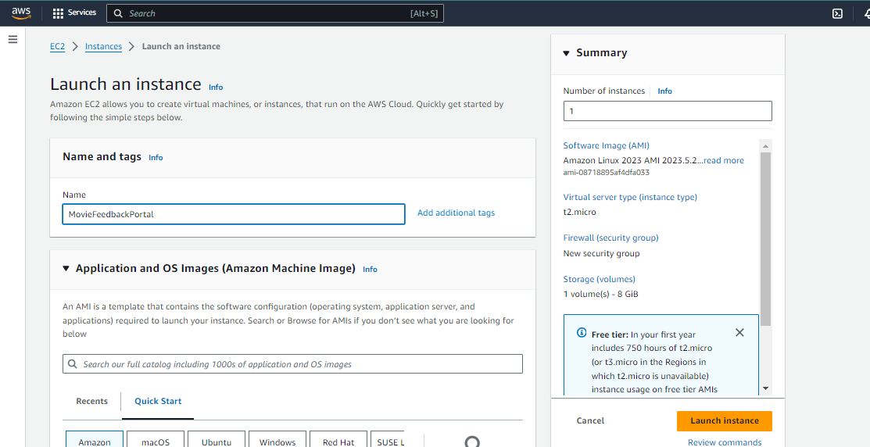

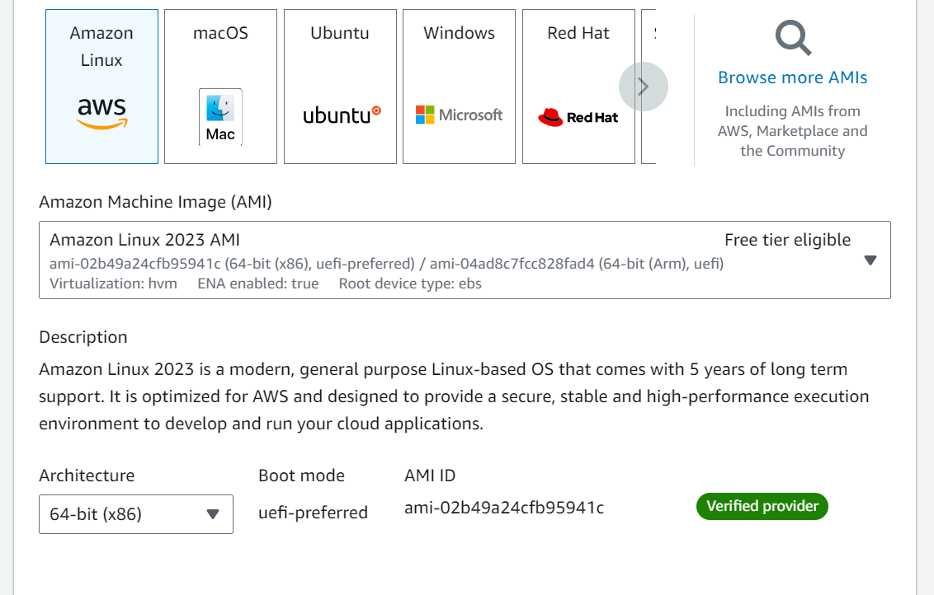

* Create a new key pair

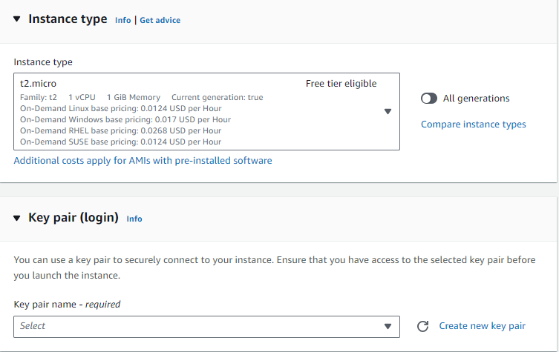

* **Activity 4.2: Configure Network Settings**
  + Set up the security group to allow HTTP, HTTPS, and SSH traffic.

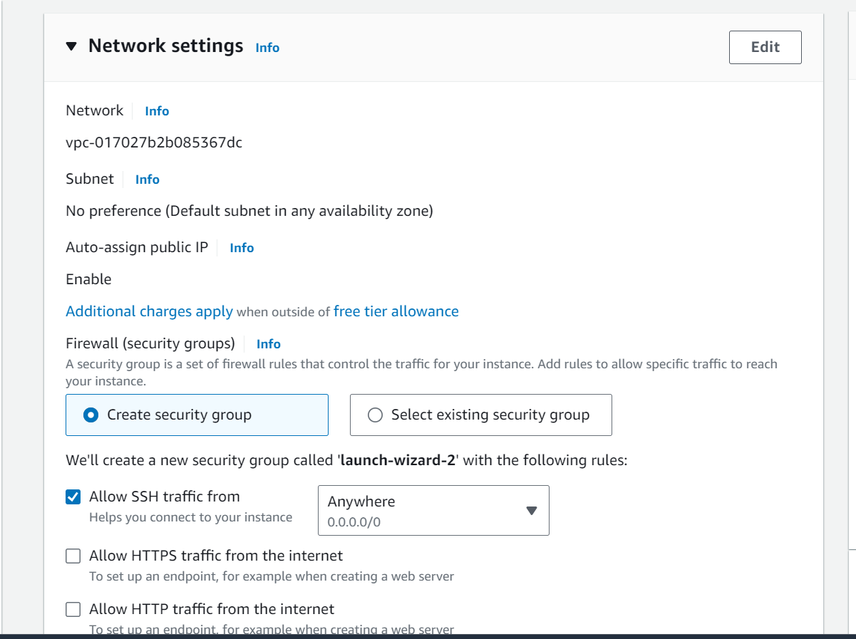

* + Create and download the key pair for SSH access.

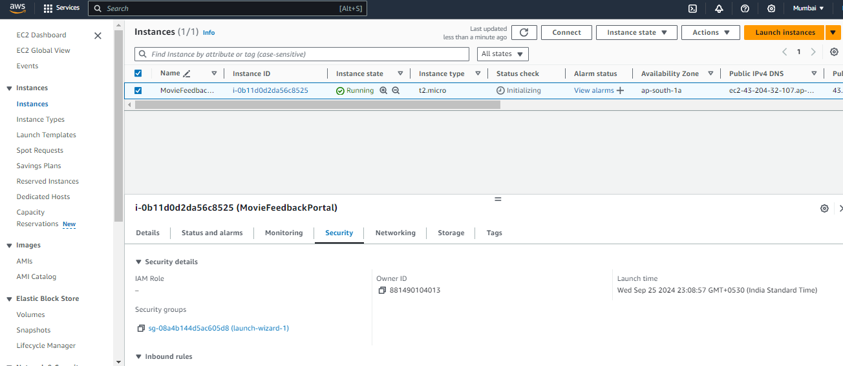

* Setting up Inbound and Outbound rules

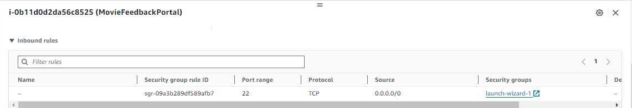

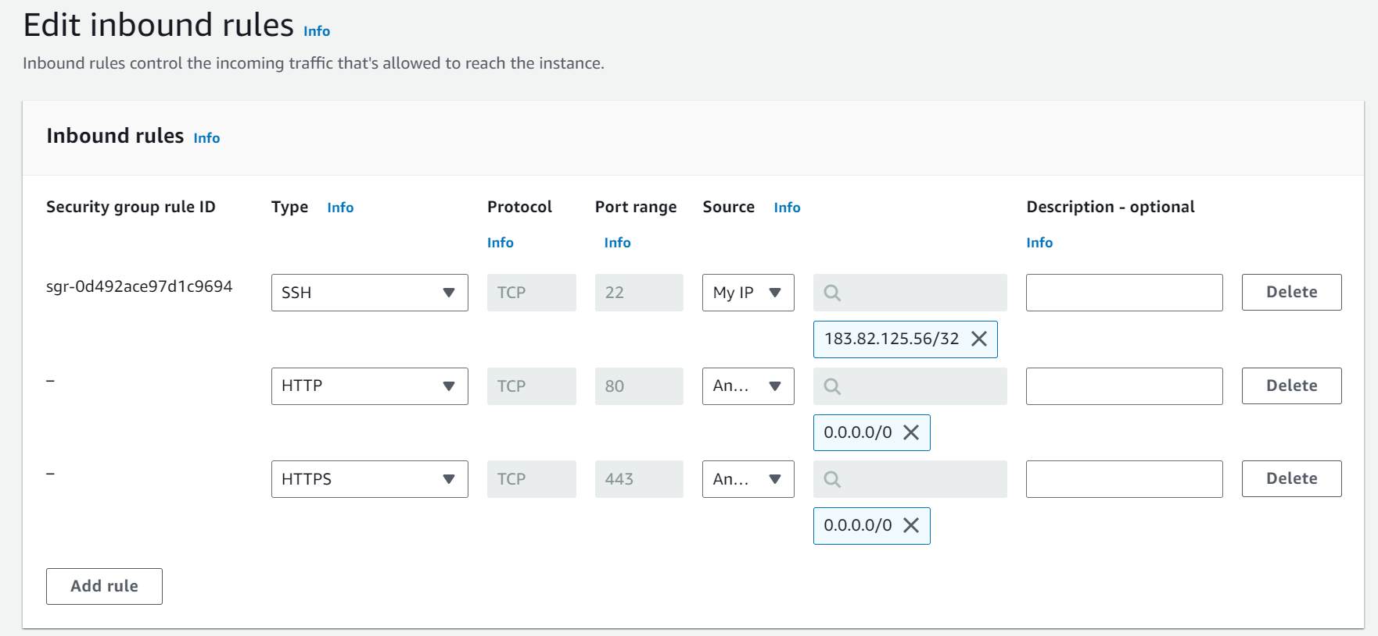

* Add Type : HTTP > Source : Anywhere
* Add Type : HTTPS > Source : Anywhere

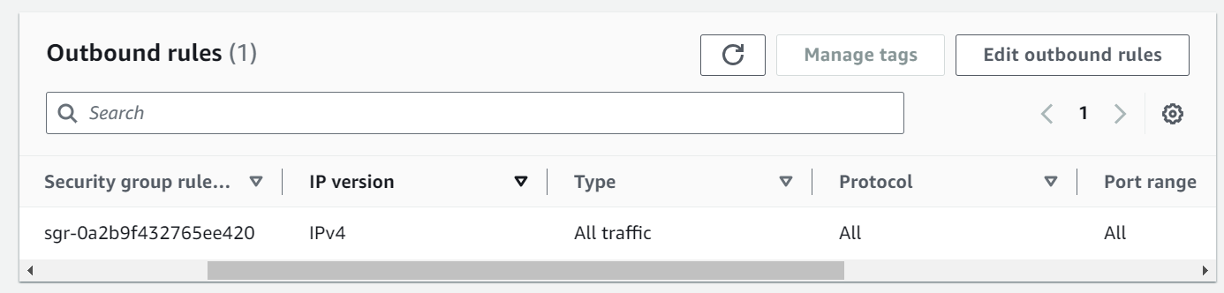

**Milestone 5: Deployment on EC2**

**Activity 5.1: Deploy to EC2**

1. Connect EC2 terminal.
2. Set up any necessary environment variables, including database connection strings.
3. Configure the web server to serve your application.
4. Start your application and ensure it's accessible via the EC2 instance's public IP or domain.

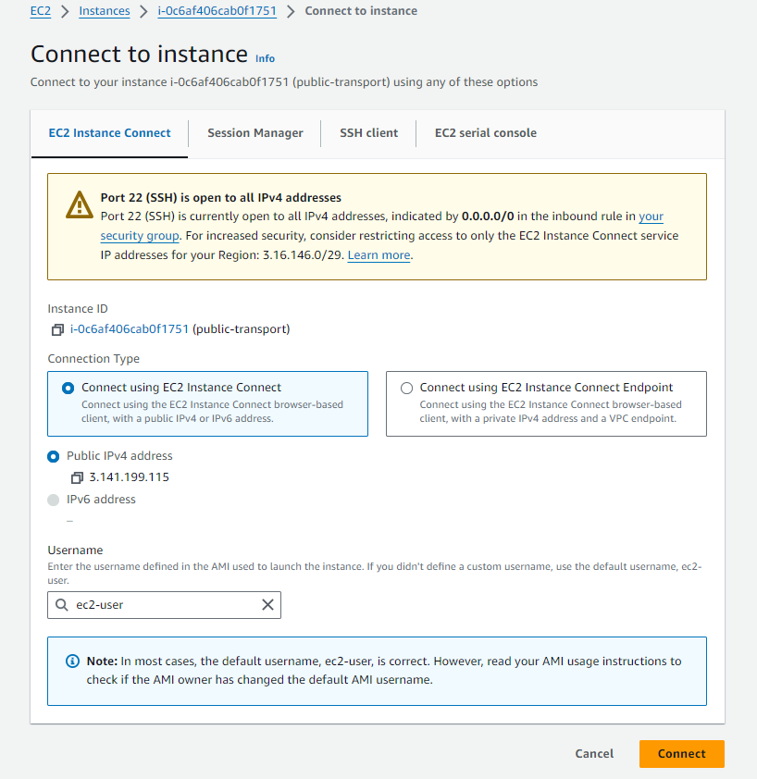

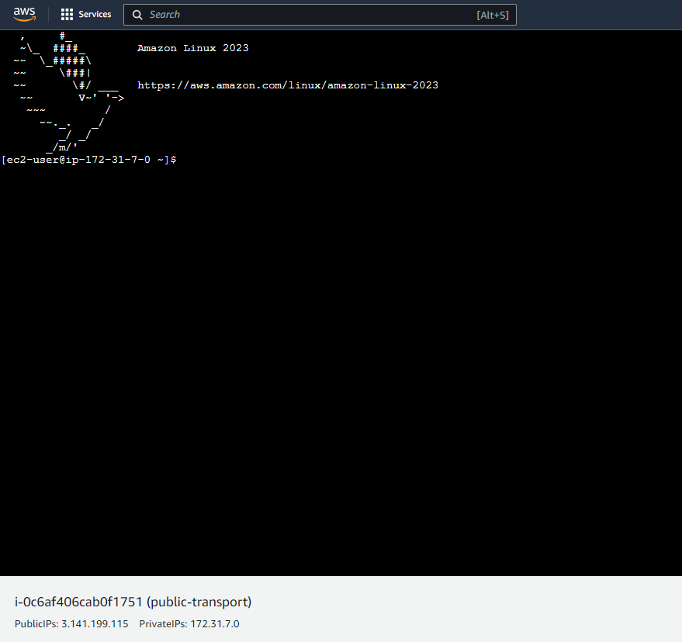

1. Run the below commands on ec2 terminal
2. sudo yum update -y
3. sudo yum install python3 -y
4. sudo pip3 install virtualenv
5. python3 -m venv venv
6. source venv/bin/activate
7. pip install flask
8. git clone <https://github.com/Pranami-1994/movie-ticket-booking.git>

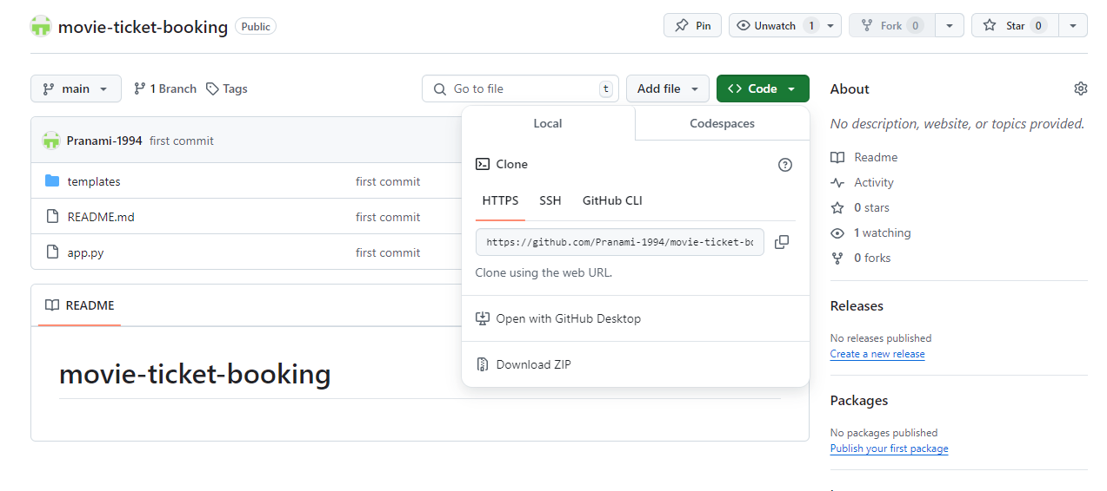

1. cd your-flask-app
2. python app.py

**Milestone 6: Testing and Deployment**

* **Activity 6.1: Functional Testing**

1. Test the CinemaBooker application for functionality, including database interactions and frontend features.
2. Run the Flask app python3 app.py
3. It will give you the link

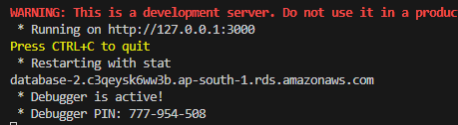

* **Activity 6.2: Deployment**
* Deploy the application in a production environment, ensuring high availability and performance.
* Click on the link above and it will take you to the webpage: [http://127.0.0.1:3000](http://127.0.0.1:3000/)

Homepage :

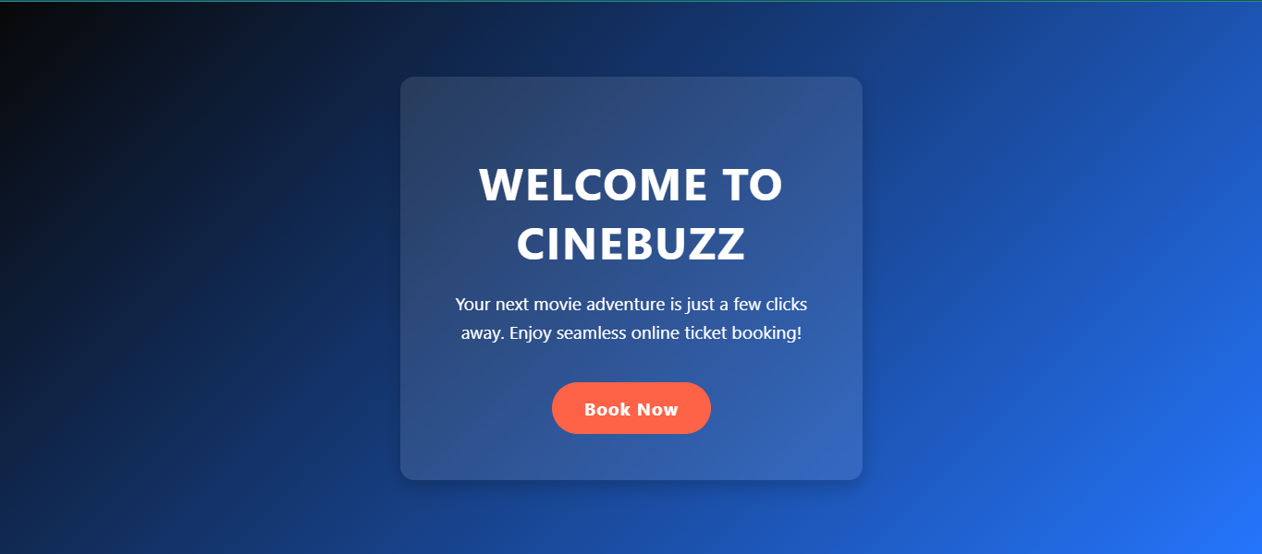

Register page: Register for movie ticket booking.  
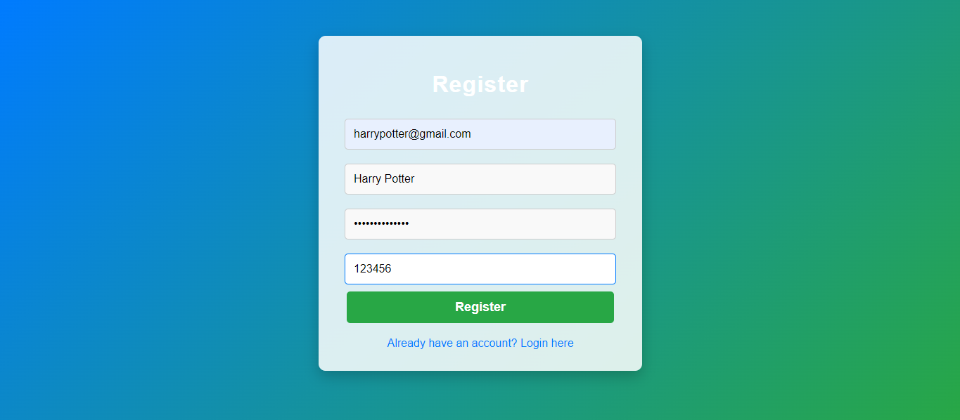  
Login page:

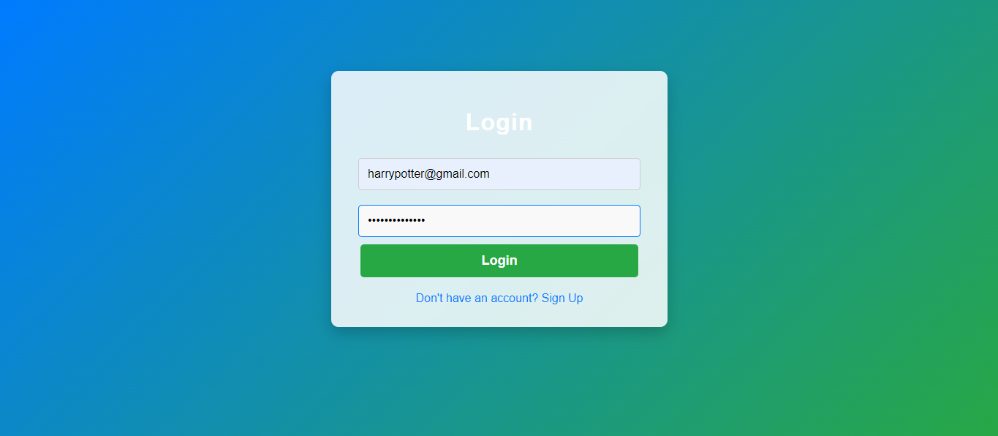  
Select_movie Page:

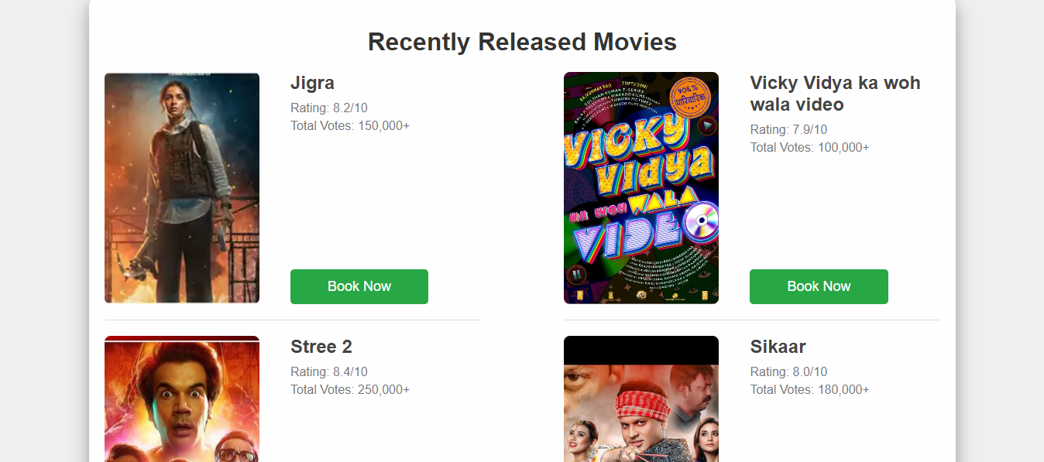  
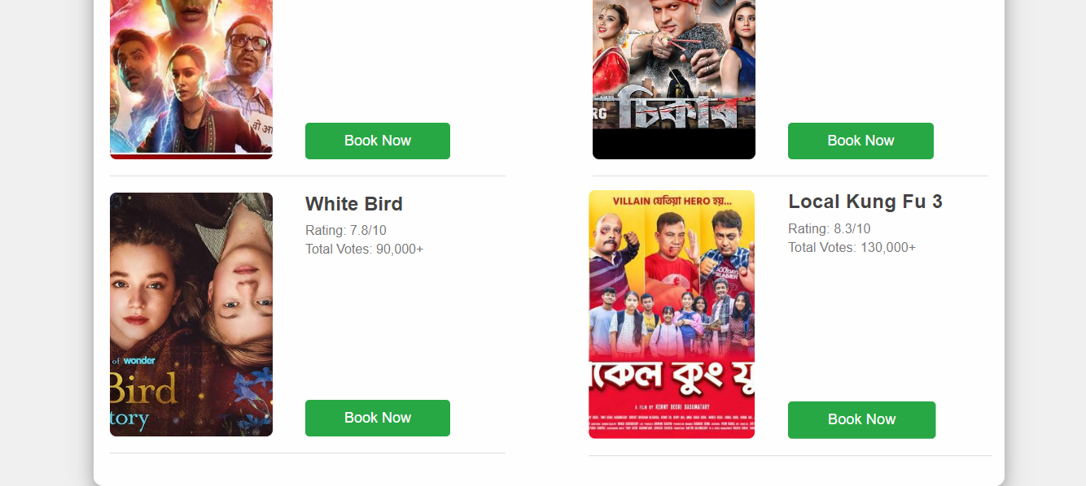

Seat page:

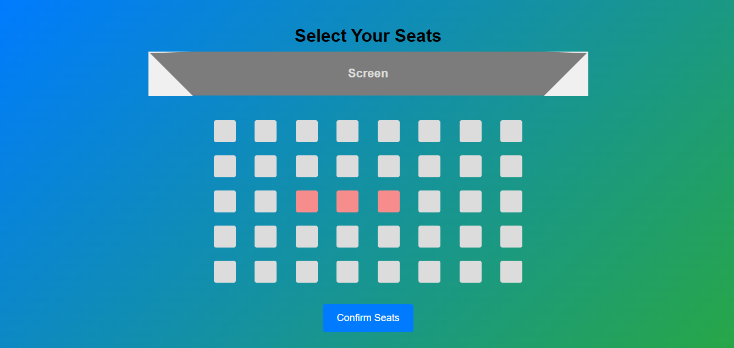  
Booking details page:

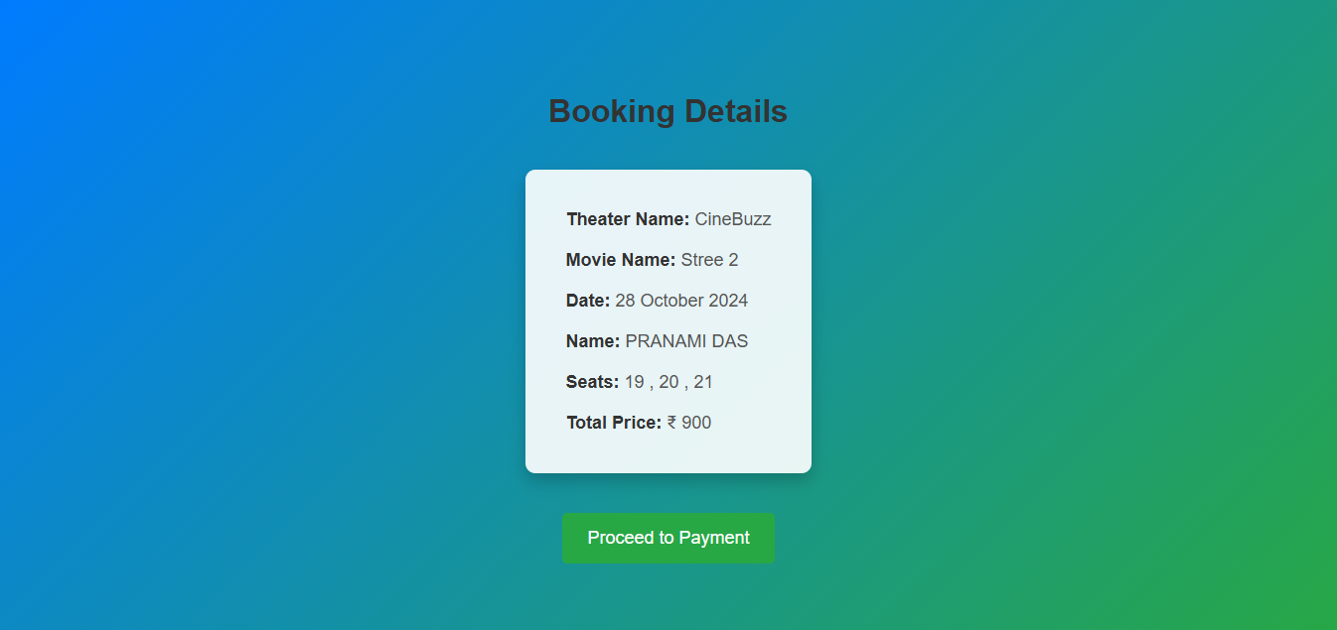  
Payment page:

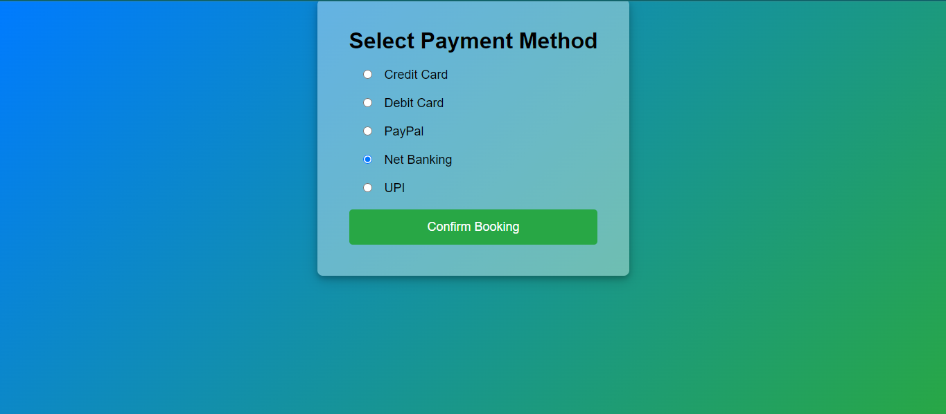

Ticket page:

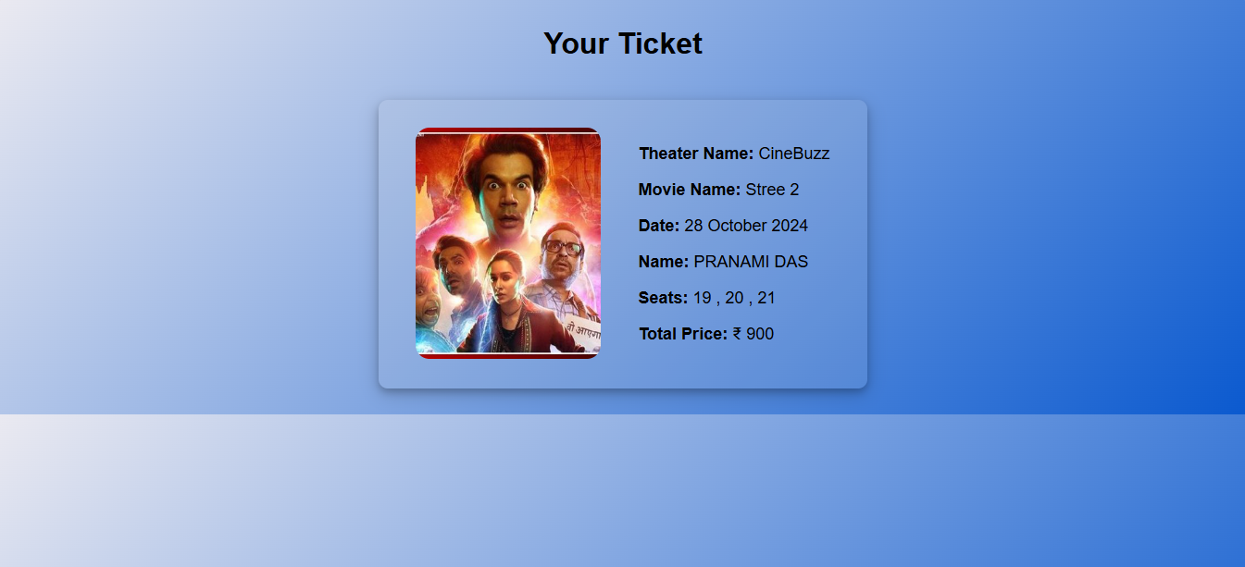

* **Activity 6.3: Check the updations in the mysql database.**

**MySql Database updations :**

MySql Database updations :

user table :

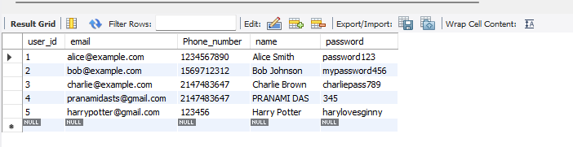

1. Movie table :  
     
   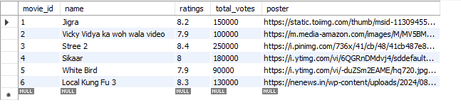
2. Booking details table:

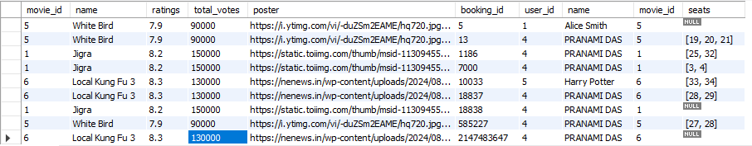

**Milestone 7: Monitoring and Optimization**

* **Activity 7.1: Performance Monitoring**
  + Set up AWS CloudWatch for monitoring EC2 and RDS performance metrics.
  + Implement alerts and notifications for critical performance thresholds.
* **Activity 7.2: Optimization**
* Optimize the server and database configurations based on monitoring results, including adjusting instance types and query optimization.

**Conclusion:**

The CineBooker project exemplifies the development of a dynamic and user-friendly movie ticket booking system powered by AWS. By utilizing Flask for backend functionality and integrating it with a robust database, the platform efficiently manages ticket sales, seat selections, and user transactions. Leveraging AWS services ensures seamless deployment, scalability, and reliability, accommodating high traffic during peak movie release periods. Every aspect, from the intuitive user interface to efficient session management, has been thoughtfully designed to enhance the overall user experience and optimize performance. This project demonstrates how cloud technologies can facilitate real-time, scalable solutions in the ticketing industry, empowering cinemas to adapt to changing demands while delivering exceptional service to their audiences.